**GUJARAT TECHNOLOGICAL UNIVERSITY**



# **Shree Swami Atmanand Saraswati Institute of Technology**

**A report on**

**AQUAPONICS FARM AUTOMATION**

**(IDP BY ROAR BIT TECHNOLOGY)**

BE Semester – VIII

Electronics and Communication **Submitted by:**

|  |  |
| --- | --- |
| **NAME** | **ENROLLMENT NO.** |
| SMITESH DHANANI  DHARA JOSHI | 150760111010  150760111026 |
| KRISHNA LAKHANI | 150760111036 |
| DEEP PADMANI | 150760111045 |
| KARTIK SOJITRA | 150760111026 |

Prof. Himanshu Rakholiya **Faculty in Guide** Prof. Avni Lakhlani  **Head of Department**

Academic Year (2019)

**Table of Contents**

**CHAPTER: 1 Introduction8**

**CHAPTER: 2 Analysis, Design Methodology and Implementation Strategy10**

**2.1** Canvas Report10

**2.1.1** AEIOU CANVAS10

**2.1.2** EMPATHY MAPING CANVAS 13

**2.1.3** IDEATION CANVAS15

**2.1.4** PRODUCT DEVELOPMENT CANVAS18

**2.1.5** BUSSINESS MODEL CANVAS21

**CHAPTER:3 DESCRIPTION23**

**3.1** Hardware Description23

**3.1.1** ATmega328p23

**3.1.2** Ultrasonic Sensor 24

**3.1.3** Transceiver Module25

**3.1.4** USB to TTL26

**3.1.5** Relay Module 27

**3.1.6** LCD (16X2)28

**3.1.7** I2C Module 29

**3.1.8** Submersible DC Water Pump30

**3.2** Software Description31

**3.1.1** Arduino IDE 31

**3.2.2** Visual Studio 31

**CHAPTER: 4 BLOCK DIAGRAM33**

**CHAPTER: 5 WORK METHODOLOGY 35**

**5.1** Flow Chart35

**5.2** Result 37

**CHAPTER: 6 ADVANTAGES 38**

**CHAPTER: 7 REFERENCE 39**

**List of Figures**

**Fig. 1(a)** Koi fish8

**Fig. 1(b)** Aquaponics system chart 9

**Fig. 2(a)** AEIOU Canvas11

**Fig. 2(b)** EMPATHY MAPING CANVAS 13

**Fig. 2(c)** IDEATION CANVAS15

**Fig. 2(d)** PRODUCT DEVELOPMENT CANVAS18

**Fig. 2(e)** BUSSINESS MODEL CANVAS21

**Fig. 3(a)** ATmega328p23

**Fig. 3(b)** Ultrasonic Sensor 24

**Fig. 3(c)** Transceiver Module25

**Fig. 3(d)** USB to TTL26

**Fig. 3(e)** Relay Module 27

**Fig. 3(f)** LCD (16X2)28

**Fig. 3(g)** I2C Module 29

**Fig. 3(h)** Submersible DC Water Pump 30

**Fig. 3(i)** Arduino IDE 31

**Fig. 3(j)** Visual Studio31

**Fig. 4(a)** Block Diagram33

**Fig. 5(a)** Flow Chart of Master 35

**Fig. 5(b)** Flow Chart of Slave 36

**Fig. 5(c)** GUI37

**Fig. 5(d)** Database37

# **CERTIFICATE**

*This is to certify that the project entitled* ***“Aquaponics Farm Automation System”*** *submitted by* ***Smitesh Dhanani*** *(Enrolment number 150760111010)* ***Dhara Joshi*** *(Enrolment number 150760111026),* ***Krishna Lakhani*** *(Enrolment number 150760111036),* ***Deep Padmani*** *(Enrolment number 150760111045),* ***Kartik Sojitra*** *(Enrolment number* *150760111053) in fulfilment of the requirement for the award of the* ***Bachelor Degree*** *in* ***Electronics & Communication Engineering*** *of the* ***Gujarat Technological University (GTU), Ahmadabad,*** *at* ***Shree Swami Atmanand Saraswati Institute of Technology, Surat,*** *is a record of his own work carried out under our supervision and guidance.*

**Prof.Himanshu Rakholiya Prof. Avni Lakhlani**

**(Project guide) (Head Of Department)**

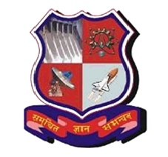

**Shree Swami Atmanand Saraswati Institute of Technology**

**Shree Swami Atmanand Saraswati Vidya Sankul, Kapodra,Varachha road, Surat-395006**

EXAMINER’S CERTIFICATE OF APPROVAL

*This is to certify that project entitled* ***“Aquaponics Farm Automation System”*** *is successfully submitted by* ***Smitesh Dhanani*** *(Enrolment number 150760111010)* ***Dhara Joshi*** *(Enrolment number 150760111026),* ***Krishna Lakhani*** *(Enrolment number 150760111036),* ***Deep Padmani*** *(Enrolment number 150760111045),* ***Kartik Sojitra*** *(Enrolment number* *150760111053)in partial fulfillment of the requirement for the award of the Bachelor Degree in* ***“Electronics And Comm. Engineering”*** *of the* ***Gujarat Technological University (GTU), Ahmedabad,*** *at* ***Shree Swami Atmanand Saraswati Institute of Technology, Surat.***

***Examiners:***

***1) _______________________***

***2) _______________________***

***3) _______________________***

***4)­­­­­­­­­­­­­­­­­ _______________________***

## **ACKNOWLEDGEMENT**

Success in such a comprehensive project cannot be achieved single-headedly. It is the team efforts that sails the ship to the cost. So, we would like to express our sincere thanks to all to dignitaries who were involved in making this project the great joy and turning it into the successful piece of work.

It was a highly eventful session at the Shree Swami Atmanand Saraswati Institute of Technology with Gujarat Technological University and highly devoted all teachers’ community and will probably remain the memorable experience of our life. Hence this acknowledgement is a humble attempt to earnestly thank all those who were directly and indirectly help to us.

We are lifelong indebted to our Project Guide **Prof. Himanshu Rakholiya**, for providing us the environment that is best suited for outgrowth of the student’s personality and bringing up their moral. We sincerely thank him for the perseverance, patience and helpfulness he has shown through the hard and easy times during the project.

|  |  |
| --- | --- |
| SMITESH DHANANI  DHARA JOSHI | 150760111010  150760111026 |
| KRISHNA LAKHANI | 150760111036 |
| DEEP PADMANI | 150760111045 |
| KARTIK SOJITRA | 150760111026 |

### **Chapter 1**

**INTRODUCTION**

* The simplest definition of Aquaponics **is the combination of aquaculture (raising fish) and hydroponics (the soil-less growing of plants)** that grows **fish** and **plants** together in one integrated system.
* The fish waste provides an organic food source for the plants, and the plants naturally filter the water for the fish.
* Aquaponics is a big hope for sustainable organic crop production, aquaculture and water consumption. The fish waste is recycled and used for plant growth instead of throwing it in the ocean. The water is recirculated in a closed system lowering the consumption of this resource.
* Koi are great for your Aquaponics system.

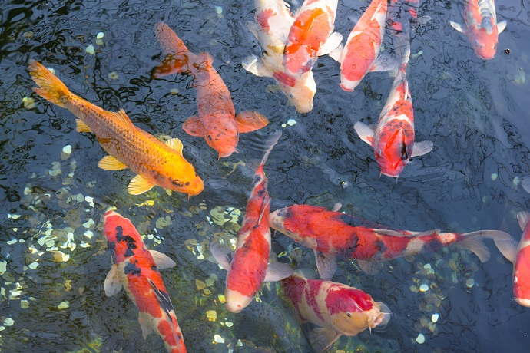

**Fig. 1(a)** Koi fish

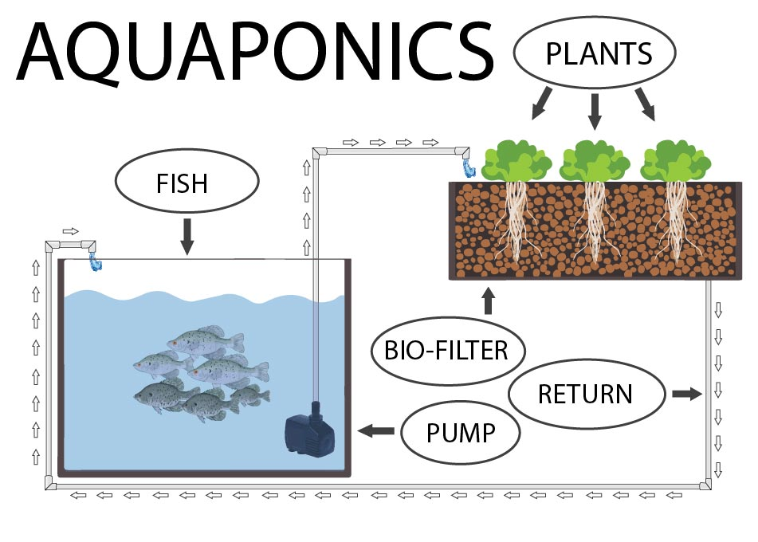

**Fig. 1(b)** Aquaponics system chart

* Aquaponics is a combination of aquaculture, which is growing fish and other aquatic animals, and hydroponics which is growing plants without soil.
* Aquaponics uses these two in a symbiotic combination in which plants are fed the aquatic animals’ discharge or waste. In return, the vegetables clean the water that goes back to the fish.
* Along with the fish and their waste, microbes play an important role to the nutrition of the plants. These beneficial bacteria gather in the spaces between the roots of the plant and converts the fish waste and the solids into substances the plants can use to grow. The result is a perfect collaboration between aquaculture and gardening.

### **Chapter 2**

### **ANALYSIS, DESIGN METHODOLOGY AND IMPLEMENTATION STRATEGY**

#### **2.1 Canvas Report**

#### **2.1.1 AEIOU Canvas**

In this canvas first we clear about the meaning of AEIOU.

A - Activity

E - Environment

I - Interaction

O - Object

U – Users

This is the way that we can make this canvas as per our domain. Which type of activities are doing in agriculture? Which type of environment we want to create? Which type of object needs in activities? And the most important thing who one can use?

This are the basic question that we can discuss and interchange the ideas then this idea can write in sticky note and stick it in our canvas.

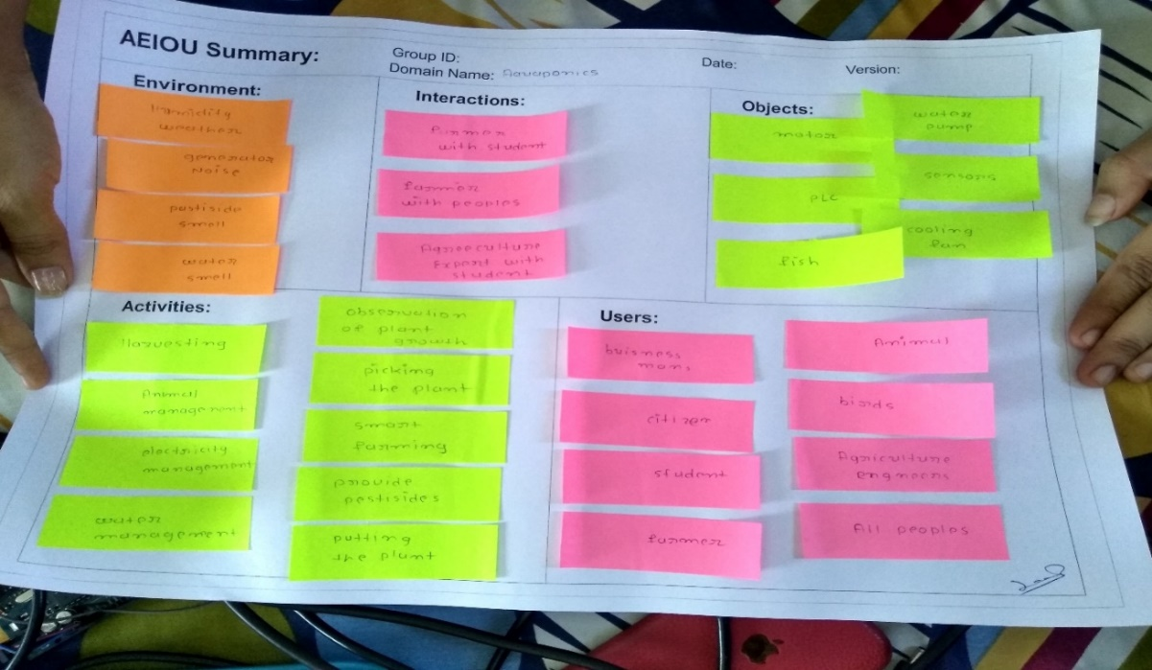

**Fig. 2(a)** AEIOU Canvas

##### **Activity**

* Crop selection
* Plugging seeds
* Buying Seeds
* Wait for plant growth
* Care of growth
* Pumping the water
* Growing Seeds
* Storing Crop
* Selling Crop
* Money Management
* Farming Training

##### **Environment**

* Sunny
* Rainy
* Spring
* Greenery
* Cold session
* Airy environment
* Humidity Weather

##### **Interaction**

* Farmer with water pipe Farmer with pump
* Farmer to Storage Provider

##### **Object**

* Seeds
* Bucket
* Rope
* Storage place Cart
* Gardening tools
* Hammer

##### **Users**

* Farmer
* Workers
* Student
* Teacher
* Business men
* Seller of seeds

#### **2.1.2 Empathy Mapping**

For making this canvas we have to heard about the word ‘Empathy’.

Before making this sheet we can remove the confusion between Empathy and Sympathy in team members. Empathy means ‘the ability to understand and share the feelings of another’. And sympathy means ‘feelings of pity and sorrow for someone else's misfortune’. Then after we write about who is stockholders of agriculture? Which type of activities we can apply in farm for batter profit? Etc. and also include two story one is happy moment based on agriculture and second is sad moment based on Empathy and Sympathy. This story we have found from farmer’s discussion that day we meet and visit his farm and stick this think in canvas. At this stage we will discover and learn about the emotions aspect of our user. This stage will involve use of empathy map. In the empathy canvas there are three mainly process is done.

1. Understand your user.
2. List user activities.
3. Create stories about your user.

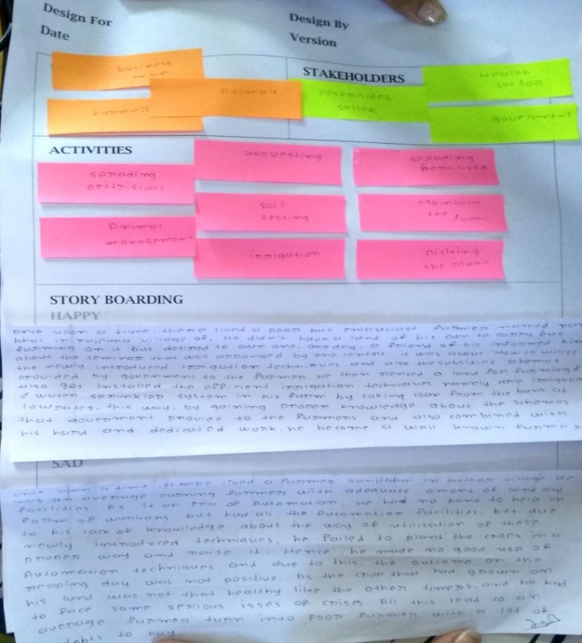

**Fig. 2(b)** Empathy Mapping Canvas

##### **Users**

* Farmer
* Workers
* Seller of pesticides
* Student
* Teacher
* Business men

###### **Stake Holder**

* Equipment Seller
* Distributors & Money management
* Researchers
* Storage Provider

###### **Activity**

* Crop selection
* Plugging seeds
* Buying Seeds
* Wait for plant growth
* Care of growth
* Pumping the water
* Growing Seeds
* Irrigation
* Storing Crop
* Selling Crop
* Money Management
* Farming Training

###### **Story Boarding**

**Happy Story**

Once upon a time, there lived a poor but enthusiast farmer named ram Bhai in rajpura village of Rajkot district. He didn't have a land of his own to carry out farming on it but desired to own one. One day, a friend of his informed him about the seminar/workshop that was arranged by "The Indian Council of Agricultural Research", which was about" How to utilize the newly introduced irrigation techniques and also the subsidies schemes provided by government to the farmers". He being the enthusiast attended a seminar/workshop and let himself receive information. He then rented a land for farming and also got installed the efficient irrigation techniques namely drip irrigation system and water sprinkler system in his farm by taking loan from the bank at low rates. That year, due to his wit and hard work, at the time of harvesting, he was able to reap much healthy crop and all this lead him to earn profit. And hence he bought that very land and also paid the debts back to the banks. This way, by gaining proper knowledge about the schemes that government provide to the farmers and also combined with his hard and dedicated work, he became a well-known farmer.

**Sad Story**

Once upon a time, there lived a farmer named in Kathor village. He was an average earning farmer with adequate amount of land and facilities. As it is an era of automation, he had no hand to help in form of workers, but had all the automation facilities. But due to his lack of knowledge about the way of utilization of these newly introduced techniques, he failed to plant the crops in a proper way, and raise it. Hence, he made no good use of the automation techniques and due to this, the outcome on the reaping day was not positive. As the crop that had grown on his land was not that healthy like the other times, and he had to face some serious issues of crises. All this lead to an average farmer turn into a poor farmer with a lot of debts to pay.

#### **2.1.3 Ideation Canvas**

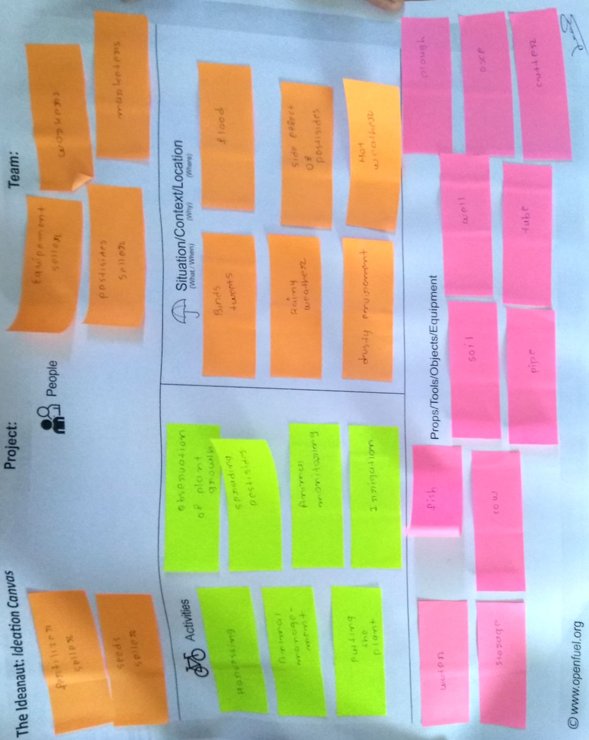

**Fig. 2(c)** Ideation Canvas

The first thing is that we have to clear about the word ‘IDEATION’.

It means the create new ideas about our domain and discuss about which type of activities we have? Which type of situation we need? Which type new tools we produce etc. After discussion stick that idea in canvas.

In this canvas first we discussed about people related to agriculture like farmer is main user and then distributor and money maker, equipment seller, etc. Then activates like harvest, farming training, cultivation, etc. Then we go farm to study SITUATION related agriculture. And then we search TOOLS/OBJECTS/EQUIPMENT in agriculture like axe, water pump

**People**

* Farmer to Equipment Seller
* Farmer to Distributers & Money Market
* Farmer to Storage Provider
* Farmer to worker

##### **Activity**

* Crop selection
* Buying Seeds
* Wait for plant growth
* Care of growth
* Pumping the water
* Growing Seeds
* Storing Crop
* Selling Crop
* Money Management
* Farming Training

##### **Situation/Context/Location: -**

* Rainy Weather
* Cold Weather
* Hot Weather
* Fish Health Issues
* Equipment Not Working
* Over Repairing of Crop

##### **Props/Possible Solution: -**

* Soilless farming
* Crop Selection Helper
* Crop Analyzer
* Agricultural income

#### **2.1.4 Product Development Canvas**

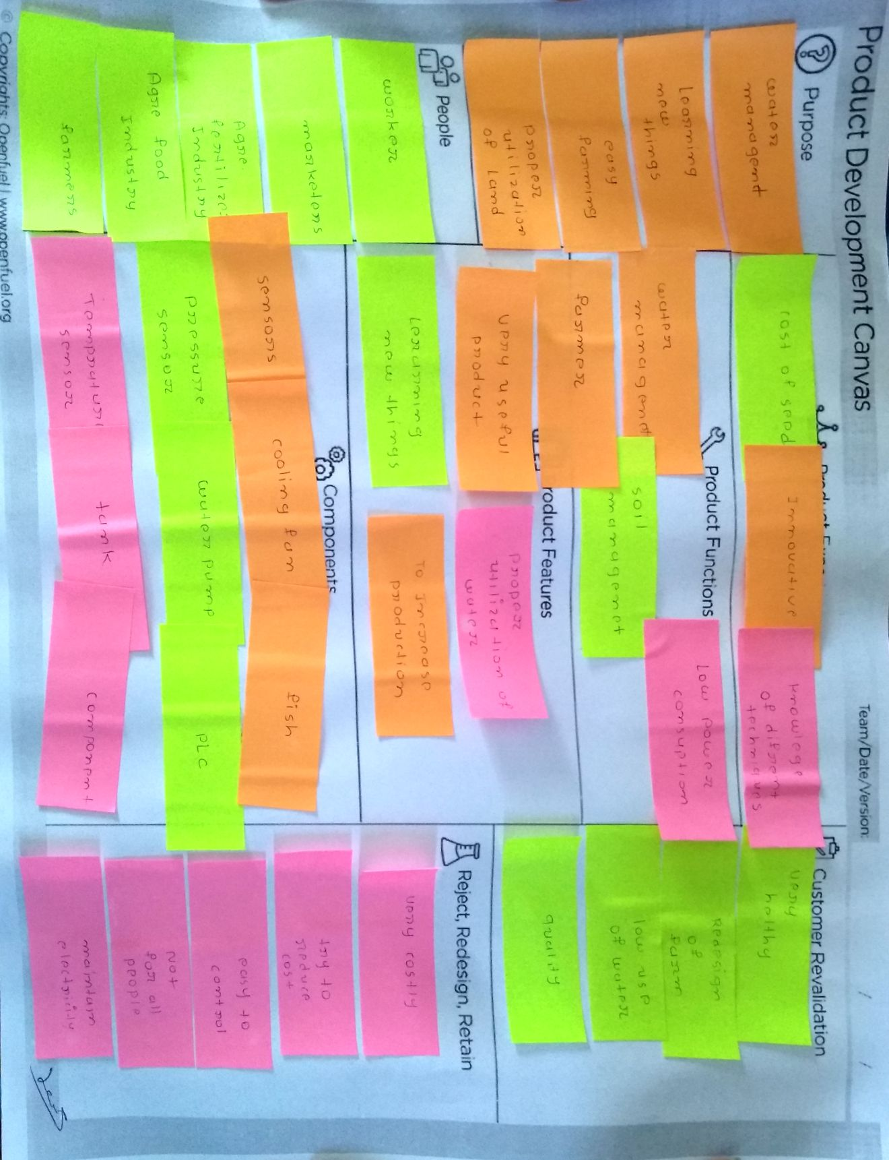

**Fig. 2(d)** Product Development Canvas

In this canvas we can identify our product, product features, what is new in our product and how to sell this product and take different type of people’s review and suggestion. And improve the product as per suggestion and review.

Here we try make farm control on automation or try to solve the water problem and electricity problem. Same as we meet different type of people and take review. We also meet Guidant of our team Prof. Himanshu Rakholiyaand show our product he asks some question like what is purpose of your product? Which type of people are used your product? What is the function of product? Etc. And last he suggests the make dirty model of your product or system which can we implement in farm.

##### **Purpose**

* Help people to Manage Soilless farming
* Water management
* Learning new things
* Proper utilization of land
* Easy farming

##### **People**

* Agriculture Department
* Labor of agriculture department
* Worker
* Farmer
* Marketers

##### **Product Experience**

* innovative
* cost of seed
* knowledge of different techniques

##### **Product Function**

* Crop Selection
* Water management
* Low power consumption
* No soil needed

##### **Product Feature**

* Very useful product
* Learning new things
* Proper utilization of water
* To increase production

##### **Components**

* Computer
* Ultrasonic sensor
* Fish
* Transceiver module
* Water pump
* Tank
* ATmega328p microcontroller

##### **Consumer Revalidation**

* Very healthy
* Easy to parches
* Redesign of farm
* Low cost
* Useful for plant
* Low west of water
* Good quality

##### **Reject, Redesign, Retain**

* Very costly
* Easy to control
* Try to reduce cost
* Not for all people
* Maintain electricity

#### **2.1.5 Business Model Canvas**

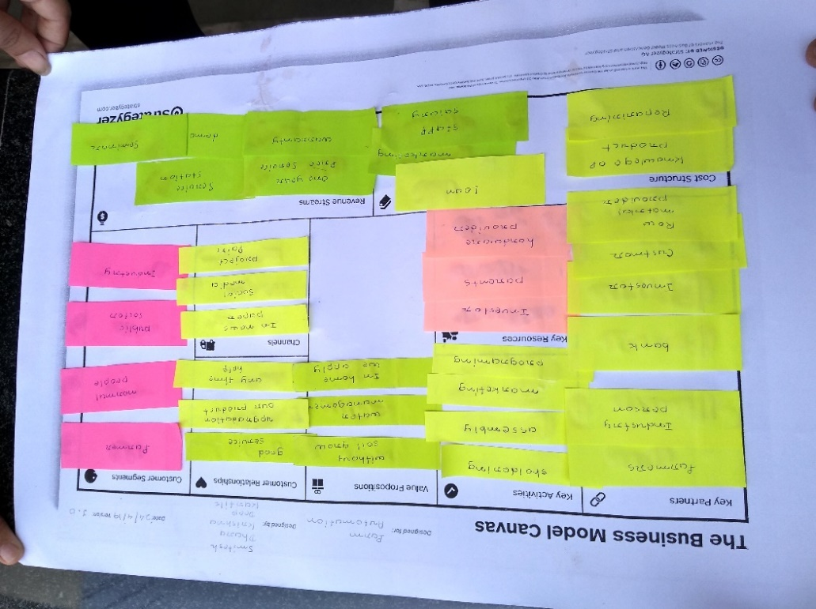

**Fig. 2(e)** Business Model Canvas

**Key Partners**

* Investors
* Industry person
* Bank
* Customer
* Raw material provider

**Key Activity**

* Programming
* Marketing
* Assembly

**Key Recourses**

* Good sevice
* Ant time assistance
* Upgradation in product

**Customer Relationship**

* Good sevice
* Any time assistance
* Upgradation in product

**Customer Segment**

* Government
* Private industry
* Public sector

**Cost Structure**

* Reparing
* Marketing
* Loan

**Value Propositions**

* Without Soil Grow
* Water Managment

**Channels**

* News paper
* Social Media
* Paplate

**Revenue Streams**

* One Year Free Service
* Service Center

### **CHAPTER: -3**

### **DESCRIPTION**

* 1. **Hardware Description:**

**3.1.1 ATmega328p: -**

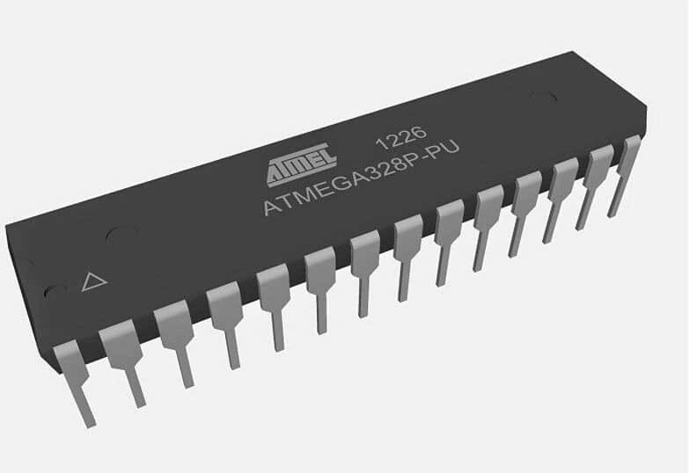

**Fig. 3(a)** ATmega328p

The Atmel AVR core combines a rich instruction set with 32 general purpose working registers. All the 32 registers are directly connected to the Arithmetic Logic Unit (ALU), allowing two independent registers to be accessed in a single instruction executed in one clock cycle. The resulting architecture is more code efficient while achieving throughputs up to ten times faster than conventional CISC microcontrollers.

The ATmega328/P provides the following features: 32Kbytes of In-System Programmable Flash with Read-While-Write capabilities, 1Kbytes EEPROM, 2Kbytes SRAM, 23 general purpose I/O lines, 32 general purpose working registers, Real Time Counter (RTC), three flexible Timer/Counters with compare modes and PWM, 1 serial programmable USARTs , 1 byte-oriented 2-wire Serial Interface (I2C), a 6channel 10-bit ADC (8 channels in TQFP and QFN/MLF packages) , a programmable Watchdog Timer with internal Oscillator, an SPI serial port, and six software selectable power saving modes

**3.1.2 Ultrasonic Sensor(JSN-SR04T-2.0): -**

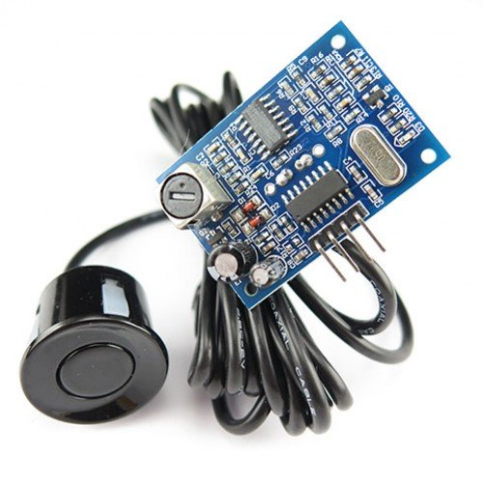

**Fig. 3(b)** Ultrasonic Sensor (JSN-SR04T-2.0)

JSN-SR0T4-2.0 ultrasonic **distance measurement** module can provide **20cm-600cm non-contact distance sensing function**, ranging accuracy **up to 2mm**; module includes the transceiver of an integrated ultrasonic sensor and control circuit. Mode one usage and the Division's JSN-SR04T-2.0 module.

This product adopts industrial-grade integrated ultrasonic probe design, waterproof type, stable performance, all the MCU on the market. 1, the module performance is stable, the measurement distance is accurate. And foreign SRF05, SRF02 and other ultrasonic rangefinder module comparable. Module high precision, blind (20cm), stable range is the product successfully to the market a strong basis.

**Features:**

* small size, easy to use;
* low voltage, low power consumption;
* high precision measurement;
* strong anti-interference;
* integrated closed waterproof cable probe, suitable for wet

**3.1.3 WIR-1186 (Transceiver Module): -**

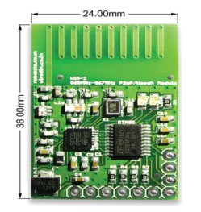

**Fig. 3(c)** WIR-1186 (Transceiver Module)

* The WIR-1186 module is a low-power wireless communication solution that is ideal for Smart Grid, home automation, smart lighting, industrial sensor data acquisition and remote control applications.

**Features:**

* VCC range: 3.2V – 3.6V supply voltage
* Range: - 2KM
* Frequency: - 865-869MHz Wireless serial link
* Standard UART interface with hardware flow-control (Clear-to-Send CTS) for long data packet handling.

**3.1.4 USB to TTL module: -**

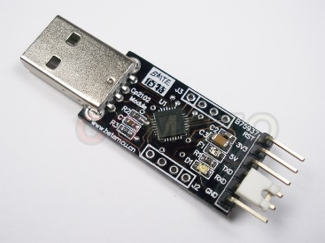

**Fig. 3(d)** USB to TTL Module

* This is an USB to TTL UART Converter module which is based on CP2102 Bridge by SiLabs. This module can be used with Laptop's which don't have standard serial port.
* This module creates a virtual COM port using USB on your computer which can support various standard Baud Rates for serial communication.

**Features: -**

* Stable and reliable chipset CP2102.
* USB specification 2.0 compliant with full-speed 12Mbps.
* Standard USB type-A male and TTL 6pin connector.
* 6pins for 3.3V, RST, TXD, RXD, GND & 5V.
* All handshaking and modem interface signals.

**3.1.5 Relay Module(JQC-3FF-S-Z): -**

The SRD-05VDC-SL-C relay has three high voltage terminals (NC, C, and NO) which connect to the device you want to control. The other side has three low voltage pins (Ground, Vcc, and Signal) which connect to the controller.

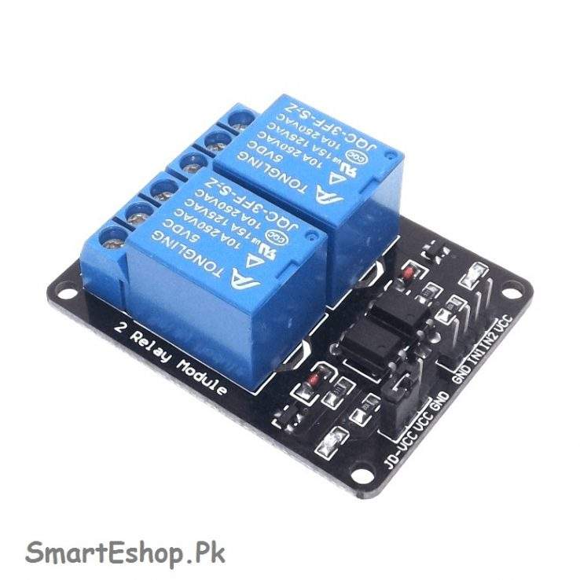

**Fig. 3(e)** Relay Module (JQC-3FF-S-Z)

**Features: -**

* 2 Channels of relay drive
* Opto-isolator driven relay
* 5V Operated
* Built-in indicator LEDs for each channel
* Equipped with 250V 10A relay
* SPDT Configuration for all relay channels

**3.1.6 LCD (16x2): -**

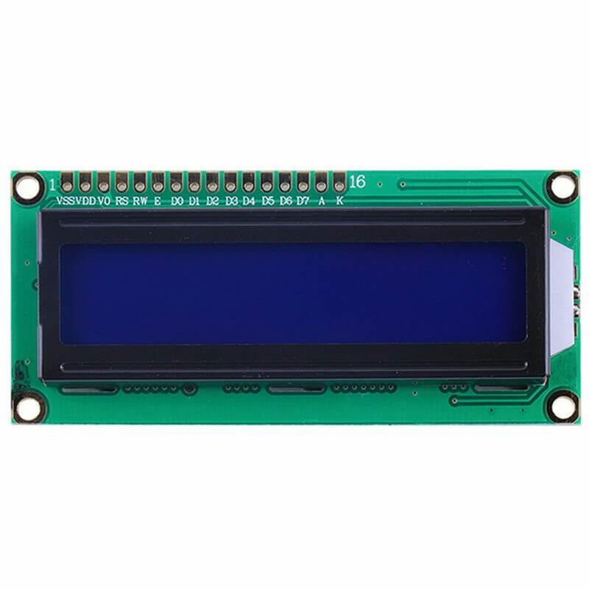

**Fig. 3(f)** LCD (16X2)

* A 16x2 LCD means it can display 16 characters per line and there are 2 such lines. In this LCD each character is displayed in 5x7 pixel matrix. This LCD has two registers, namely, Command and Data.
* LCD (Liquid Crystal Display) screen is an electronic display module and find a wide range of applications.

**3.1.7 I2C Module: -**

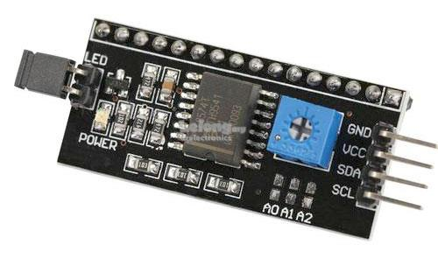

**Fig. 3(g)** I2C Module

* Serial I2C LCD display adapter converts parallel based 16 x 2-character LCD display into a serial i2C LCD that can be controlled through just 2 wires.
* Adapter uses PCF8574 chip that serves as I/O expander that communicates with Arduino or any other microcontroller by using I2C protocol.

**Features:**

* 16 x 2 Character LCD display is controlled via just two wires.
* Up to 8 LCD displays with adapters can be connected and controlled by the same two wire I2C bus.
* Easy to control using Arduino board.
* Adapter includes 16-PIN male header connector for soldering to LCD display.
* Contrast is adjusted via on-board potentiometer.
* Backlight may be turned on/off via jumper.
* Standard 5V voltage supply.

**3.1.8 Submersible DC Water Pump: -**

[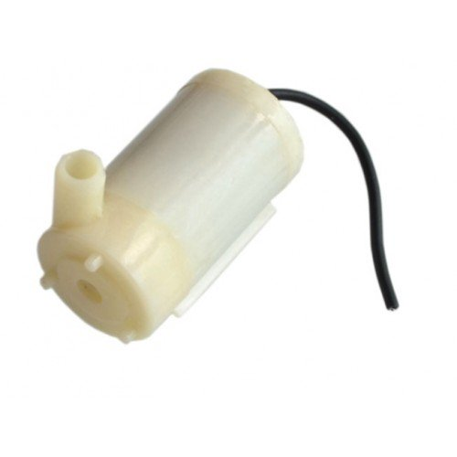](https://happyec.in/wp-content/uploads/2018/12/mini-water-pump-submersible-dc-3-6v-1508-500x500.jpg)

**Fig. 3(h)** Submersible DC Water Pump

* We use this pump to provide water circulation in all The demo model.
* We use this 12v Water Pump for demo in actual Field We use high rating pump also.

**Features:**

* Power consumption: 0.4W to 1.5W
* Rate of flow: 80 – 120L/hr
* Lift: 1.1m MAX
* Operating Voltage: 12v DC
* Type: submersible
  1. **Software Description:**

**3.2.1 Arduino IDE:**

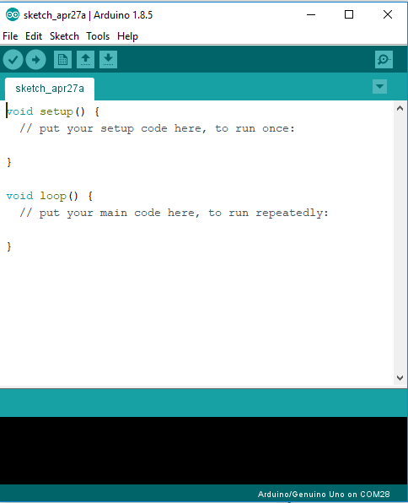

* **Fig. 3(i)** Arduino IDE
* The open-source Arduino environment makes it easy to write code and upload it to the i/o board. It runs on Windows, Mac OS X, and Linux. The environment is written in Java and based on Processing, avr-gcc, and other open source software.

**3.2.2 Visual Studio:**

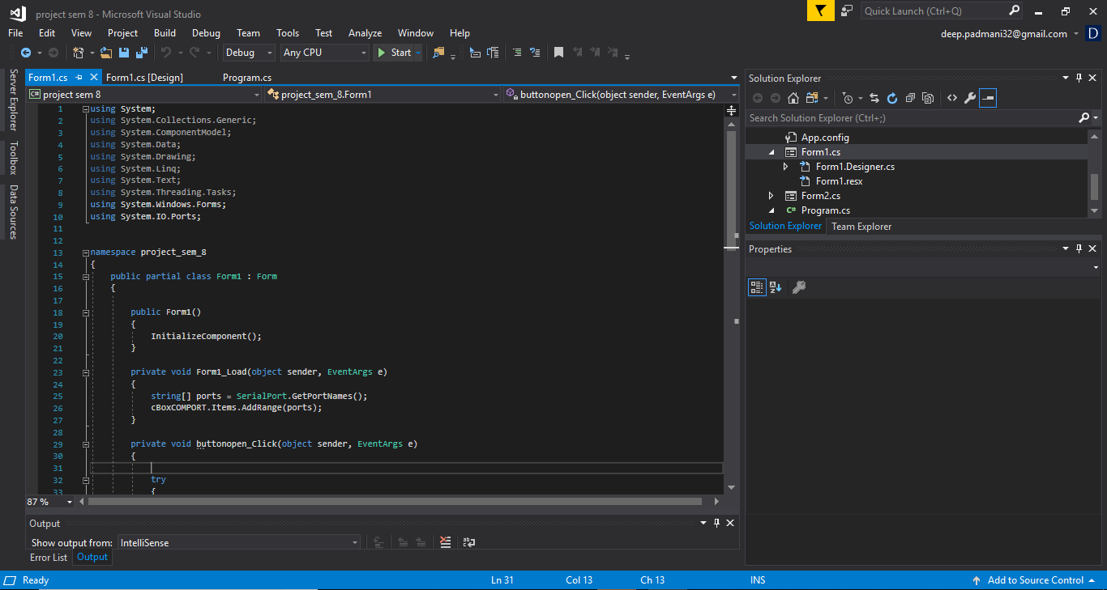

**Fig. 3(j)** Visual Studio

* In master side we made one GUI using **C#.net in Visual studio**, to operate or show the level of tank at slave side. GUI and **ATmega328p** connected with **USB to TTL** module.
* I this block we also made one **Data base**, in this all the details of slave side are saved through the **GUI**.

**CHAPTER: 4**

**Block Diagram**

**Master**

**ATmega328p**

**Water Supplier Motor**

**WIR-1186 (Transceiver Module)**

**JSN-SR04T-2.0 (ultrasonic sensor)**

**16X2 LCD with I2C Module**

**Power Supply +5V**

**USB to TTL**

**Computer**

**(GUI)**

**ATmega328p**

**Power Supply +5V**

**WIR-1186**

**(Transceiver Module)**

**Tank filler Motor**

**Power Supply +3.3V**

**Relay Module**

**Power Supply +3.3V**

**WIRELESS**

**COMMUNICATION**

**Ms Access Database**

**Slave**

**Fig. 4(a)** Block Diagram

* As shown in above block diagram main heart of our project is **ATmega328p**.
* **ATmega328p** operated with 5V power supply.
* **WIR-1186(Transceiver module)** connected with **ATmeg328p**, it is used for transmit or receive the data through PC to field side sensors.
* In master side we made one GUI using **C#.net in Visual studio**, to operate or show the level of tank at slave side. GUI and **ATmega328p** connected with **USB to TTL** module.
* I this block we also made one **Data base**, in this all the details of slave side are saved through the **GUI**.
* At slave side we also use power supply for **ATmega328p** and it is connected with **WIR-1186(transceiver module).**
* With **ATmega328p** two **JQC-3FF-S-Z (relay module)** of 1-channel are connected to operate pump. **Pump** is used to provide proper flow or maintain of water in tank.
* One relay module is connected with start pump and other one is connected with empty(stop) pump.
* At slave side main component is **JSN-SR04T-2.0(Ultrasonic sensor)**. It is used to measure the distance of water in tank.
* According to distance ultrasonic sensor give command to **ATmega328p** to on pump or off pump.
* In this format the whole process is done.

**CHAPTER: -5**

**WORK METHODOLOGY**

**5.1** **Flow Chart:**

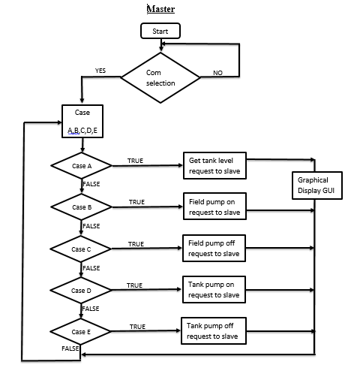

**Fig. 5(a)** Flow Chart for Master

**Slave**

Start

**Fig. 5(b)** Flow Chart for Slave

FALSE

FALSE

FALSE

FALSE

FALSE

Tank filter off plant motor off

Case

A,B,C,D,E

Case A

Case B

Case C

Case D

Case E

Send the tank level data

Field pump on request to master

Field pump off request to master

Tank pump on request to master

Tank pump off request to master

Indicate Tank level in display

NO

YES

If tank level is greater than 20cm?

TRUE

TRUE

TRUE

TRUE

TRUE

**5.2** **Results:**

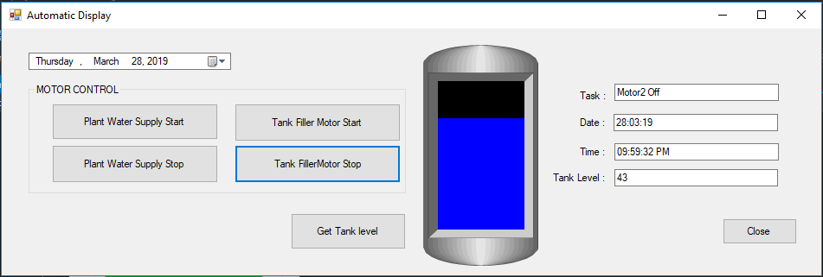

**Fig. 5(c)** GUI

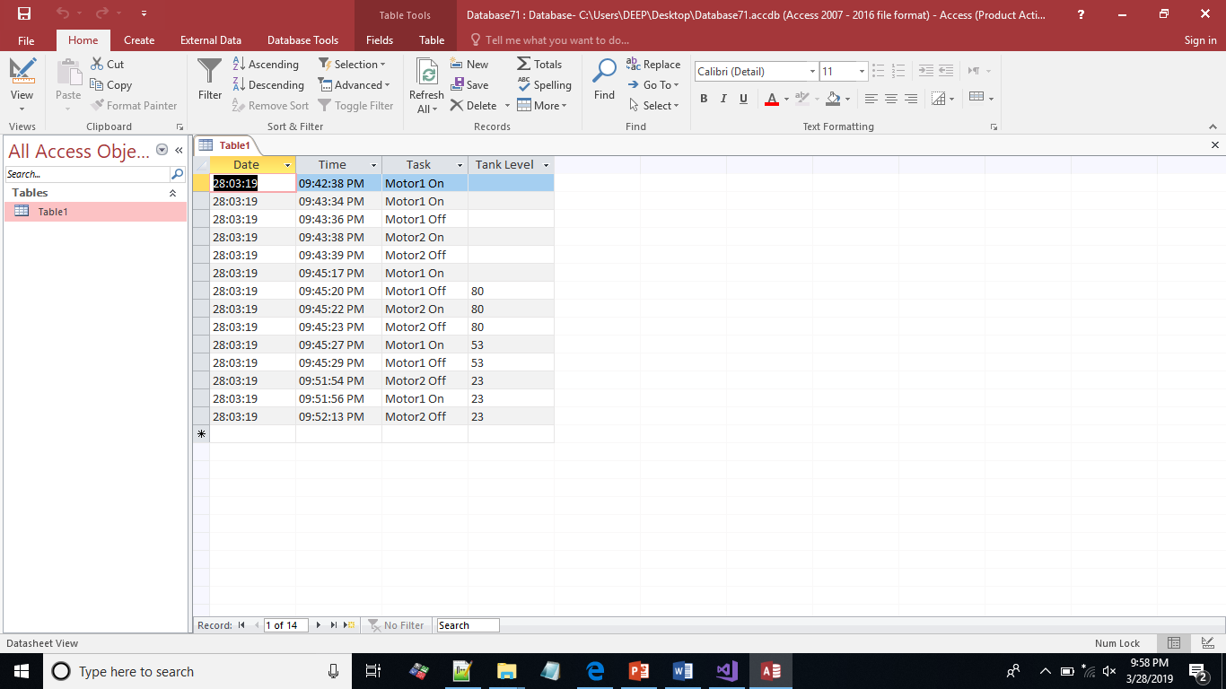

**Fig. 5(d)** Database

**CHAPTER: -6**

**Advantages**

### Aquaponics is a way to grow your own fish and vegetables at the same time. You feed the fish and the fish will feed your plants through their waste output.

### There is no need to use fertilizers because the fish provide rich nutrients for the plants.

### In aquaponics, less water is used for the crops. Research has shown that aquaponics gardens use 1/10th of the water you would use for soil garden.

### Regular gardening pesticides or other chemicals can’t be used because they would harm the fish.

### This results in healthier and organic vegetables.

### You won’t experience any soil borne diseases in aquaponics because there is no soil.

### You can grow plants in very small space, and have a great harvest.

### Plants grow fast because they get very nutritious substances from the fish waste.

### Plants and fish production can be done in a controlled temperature environment.

### Water is used in a closed system and circulated effectively, reducing the consumption and the water bills.

**CHAPTER: -7**

* **References**
* *References for Arduino: -*

[*https://www.arduino.cc/en/Guide/ArduinoUno*](https://www.arduino.cc/en/Guide/ArduinoUno)

* *References for Arduino and WIR1186 :-* [*https://github.com/askmuhsin/WIR-Arduino*](https://github.com/askmuhsin/WIR-Arduino)
* *References for C# Coding :-* [*https://en.wikipedia.org/wiki/C_Sharp_(programming_language)*](https://en.wikipedia.org/wiki/C_Sharp_(programming_language))
* *References Paper:-* [*https://ieeexplore.ieee.org/abstract/document/6650186*](https://ieeexplore.ieee.org/abstract/document/6650186)
* *What is Aquaponics Farm Automation :-*[*https://en.wikipedia.org/wiki/Aquaponics*](https://en.wikipedia.org/wiki/Aquaponics)